

SIGNIFICANT OCCURRENCE POLICY

Introduction & Objectives

  - Hartmore School refers to untoward incidents that occur from time-to-time as Significant Occurrences. Significant Occurrences include, but are not limited to:

    - Accidents
    - Onset of Serious Illness
    - Health, Safety & Welfare events and/or near misses
    - Violent and Aggressive Behaviour (including all physical interventions)
    - Criminal Behaviour including deliberate damage
    - Pupils absenting themselves from school or school trips without permission
    - Safeguarding Issues

  - This Significant Occurrences Policy (and procedures contains therein) provides a positive frame to the process of recording, analysing and learning lessons from all untoward events, including difficult and challenging behaviour.

1.2.1. The use of the language ‘Significant Occurrence’ rather than ‘incidents’), in part is to avoid the potentially stigmatising effect of a term that has come to have negative connotations.

  - This Significant Occurrences Policy aims:

    - To provide staff with an agreed method of reporting, recording, managing, investigating and reviewing Significant Occurrences.
    - To ensure that the accurate and comprehensive recording of Significant Occurrences occurs
    - To enable possible trends can be identified, and to mitigate against similar risks in the future
    - To ensure that proper analysis, reflection and learning takes place, and appropriate steps are taken to prevent similar significant occurrences in the future.
    - To provide staff with clear guidance on reporting of accidents under the RIDDOR process, and the investigation of the same

  - The overarching purpose of this Significant Occurrences Policy is to provide guidance, ensuring all communication is open, honest and occurs as soon as possible following a Significant Occurrence.

  - The purpose of reporting and investigating Significant Occurrences is to:

    - Identify risks
    - Learn from significant occurrences
    - Improve the quality of the educational experience for the pupils we support
    - Maintain the safety of the pupils, their parents/carers staff, volunteers and visitors
    - Provide real data to inform the Risk Assessment Process

  - This Significant Occurrences Policy is closely linked to the Risk Assessment Process.

Definitions

Being Open

2.1.1. Organisations are said to be ‘open’ when the prevailing culture visibly encourages key behaviours. These include honesty, openness, appropriate sharing of information and a willingness to learn from experience. Open organisation have the ability to reflect and grow, develop to change in direct response events. A commitment to improve requires a commitment always to learn lessons.

Near Miss

2.2.1. An event not causing harm, but has the potential to cause injury or ill health [Health & Safety Executive (HSE) October 2016].

  - Accident/Incident

2.3.1. An event that results in injury or ill health [HSE October 2016].

Significant Occurrence Definition & Classification

  - A Significance Occurrence is any event that has results in injury, ill-health or significant emotional distress. Included within this definition are ‘near misses’; that is events that do not result in immediate injury or ill-health, but have the potential to so.

3.2.1. Insignificant

    - An event that had the definite potential to cause harm, damage, loss or other jeopardy, but where no actual harm results.

    - An event that causes harm, damage, loss or other jeopardy, but where it is very minor (very short- term effects, no first aid or medical intervention required, no debilitation, very temporary and limited distress only.

    - An event which was not intended nor had the potential to cause physical harm, but nevertheless caused a small amount of distress or discomfort e.g. swearing, insulting or threatening someone.

Minor

    - An event that causes actual harm, damage, loss or other jeopardy, but where that harm, damage, loss or other jeopardy is only of minor nature. That is, no long-lasting effects, easily treated with first aid, limited debilitation, short-lived and minor distress only.

    - This might include:

      - Directed one-off verbal abuse
      - Minor incidents of bullying Minor injuries requiring first aid
      - Illness that requires the child go home (rather than needing medical attention)

    - Includes Safeguarding events that do not meet the threshold for further formal investigation.

    - Includes events that had the potential to cause significant or very significant harm, but in fact only caused insignificant harm.

Moderate

  - An event that causes actual harm, damage, loss or other jeopardy, and where that harm, damage, loss or other jeopardy is of a moderate nature.

    - Moderate events may include:

      - Illness or injury that requires attendance at accident and emergency department, or emergency treatment from a medical professional (though not overnight stay in hospital)
      - An injury to a pupil or member of staff that makes it unable for them to attend school for at least one day
      - Behaviour that requires staff to physically intervene (including physical restraint)
      - An event requiring the involvement of the police (though no arrests) (including minor vehicle accidents)
      - A pupil/s missing from the school for more than hour and less than four hours (or a very vulnerable child missing for a shorter period as defined by the relevant risk assessment)
      - Moderate damage to property
      - On-going verbal abuse exacerbated by swearing, racist, sexist, homophobic abuse or other prejudicial behaviour
      - On-going bullying, focused primarily on verbal threats, with only minor or insignificant physical threats or actions
      - Any event that causes an injury to staff requiring they take time off work, but does not meet the RIDDOR threshold
      - Consensual, developmentally normative sexual contact between pupils
      - Inappropriate sexualised behaviour including minor transitory sexual suggestions, minor verbal harassment

    - Also includes events that had the potential to cause significant or very significant harm, but in fact only caused minor harm.

Significant

    - An event that causes actual harm, damage, loss or other jeopardy, and where that harm, damage, loss or other jeopardy is of a significant nature.

    - Significant events may include:

      - Illness or injury that requires attendance at accident and emergency department, or emergency treatment from a medical professional that necessitates at least one night’s overnight stay in hospital)
      - An injury to a pupil or member of staff that makes it unable for them to attend school for at least one week
      - Physical assault resulting in actual injury
      - An event requiring the involvement of the police following a minor crime being committed
      - A motor vehicle accident involving a second vehicle and/or where any person receives minor injuries
      - A pupil/s missing from the school for more than four hours and but not overnight (or a very vulnerable child missing for a shorter period as defined by the relevant risk assessment)
      - Significant damage to property
      - On-going threatening behaviour direct at an individual that maybe exacerbated by swearing, racist, sexist, homophobic abuse or other prejudicial behaviour
      - On-going bullying, focused primarily on physical threats, with moderate physical threats or actions
      - Any event that causes an injury to staff requiring they take time off work that meets the RIDDOR threshold
      - Developmentally concerning sexual contact between pupils (including concerns regarding informed consent)
      - Inappropriate sexualised behaviour including sexual threats, harassment and/or inappropriate touching/exposure
      - Suspicion of Child Sexual Exploitation

    - Also includes events that had the potential to cause very significant harm, but in fact caused major or significant harm.

Very Significant

    - An event that causes actual harm, damage, loss or other jeopardy to a very significant nature. To include life-changing or long-lasting injury.

    - Significant events may include:

      - Illness or injury that requires transfer to hospital by ambulance, emergency treatment from a medical professional and necessitates a prolonged stay in hospital
      - An injury to a pupil or member of staff that makes it unable for them to attend school for at least four weeks
      - Physical assault (consisting of a serious criminal offence) resulting in very significant injury
      - An event requiring the involvement of the police following a serious crime being committed
      - A motor vehicle accident involving a second vehicle and/or where any person receives major injuries/need for hospitalisation
      - A pupil/s missing from the school overnight (or a very vulnerable child missing for a shorter period as defined by the relevant risk assessment)
      - Very significant damage to property
      - On-going bullying, including physical significant physical aggression, theft, sexual exploitation
      - Any event that causes a serious injury to staff requiring they take extended time off work (and that meets the RIDDOR threshold)
      - Non-consensual sexual contact between pupils (including concerns regarding informed consent)
      - Inappropriate sexualised behaviour including sexual threats, on-going significant harassment and/or assault
      - Evidence of Child Sexual Exploitation

  - The above classification examples are not definitive, but are intended as a guide only. Each Significant Occurrence requires careful consideration and professional judgement. It is the ultimate responsibility of the Headteacher to accurately categorise each event, to discuss following discussion as necessary with colleagues.

Reporting Significant Occurrences

  - If staff become aware of an ongoing significant occurrence, they should take any immediate action necessary to make the situation safe (including securing their own safety, and that of pupils and others involved).

4.1.1. As soon as is safe and practicable, a member of staff should notify the Headteacher (or in his absence, the most senior the most senior colleague available).

  - As soon as is convenient after a Significant Incident, staff involved should complete a Significant Occurrence Form (SOF) (See Appendix II). Where required, additional detail or information should be added to the SOF in the way of Appendices.

    - Staff not be directly involved in a Significant Occurrence, but who are witnesses, should also contribute to the SOF, either as the ‘lead writer’, or to add additional detail.

    - Where applicable, staff should also complete an Accident Form (in the Accident Book held in the School office).

  - As with all records, when completing an SOF, staff must provide as honest and comprehensive account of the event as possible. It should be factual and avoid all speculation on motive. Opinion should be avoided.

  - On completion, Significant Occurrence Forms should be sent to the Headteacher.
  - Significant Occurrences pertaining to Health, Safety & Welfare and/or that require the completion of an Accident Form following an injury to a member of staff should be notified to the Headteacher as soon as possible.

  - All Significant Occurrences are placed on the agenda for the next Weekly Meeting for discussion and review.

Headteacher

  - The Headteacher should be sent a copy of all Significant Occurrence Form via email, the same day or within one working day.

  - The Headteacher should:

    - Review the SOF as soon as possible
    - Ensure that all external individuals and agencies e.g. Parents/carers, LADO, social worker, LEA, others are informed as appropriate (including providing completed copies of Significant Occurrence Forms)
    - Complete the Headteacher’s Review Section
    - Sensitively review the appropriateness of the grading of the Significant Occurrence, and place their own grade on the Headteacher’s Review Section
    - Ensure all other relevant documentation and records are completed
    - Arrange to (or arrange for a nominated person to) meet with the pupil to ask their views on the significant occurrence, and how it was managed. Care should be taken to establish any additional underlying causes (based on evidence not speculation)
    - Ensure Risk Assessments are updated in the light of the significant occurrence
    - Identify any learning and arrange the mechanism for sharing that learning with the relevant individuals, and the whole team, as appropriate
    - Review most carefully all and any occurrence that involved physical intervention, as soon as possible following the occurrence
    - Ensure that there is an analysis of the significant occurrences within the school
    - Maintain a record of all analysis and review of Significant Occurrences.

Investigations & Learning Lessons

  - As seems appropriate, the Headteacher request/undertake a ‘formal investigation’, beyond the analysis and action taken for every Significant Occurrence. He may do this because the event initially appears as though it could have been better managed/avoided, and therefore lessons for the future need to be learnt.

  - Any Significant Occurrence categorised as ‘Very Significant’ must be subject to a ‘formal investigation’.

  - Any Significant Occurrence that appears to involve misconduct by a member of staff that may lead to disciplinary action must be subject to a ‘formal investigation’.

13.3.1. It may be necessary that during the ‘formal investigation’, member/s of staff need be informed that the matter is to be dealt with in accordance with the Disciplinary Policy.

  - The Headteacher may carry out this investigation themselves or nominate an ‘investigating officer’ to lead and coordinate the investigation.

  - In the normal course of individual supervision, the member of staff involved must have the opportunity to reflect on every Significant Occurrence they have been involved with or witnessed.

Review

  - This Policy was last reviewed in September 2025 and will next be reviewed in September 2026.

Appendix I

SIGNIFICANT OCCURRENCE REPORT

Significant Report No. |  |  |  |  | Missing from School No. |  |  |  |  |  |  | Physical Intervention No.
Author’s Grading of Occurrence (Seriousness)
Insignificant |  | Minor |  |  |  | Moderate |  |  |  |  | Significant |  |  | Very Significant
Pupil Involved |  |  |  |  |  |  |  |  | DoB
Date of Occurrence |  |  |  |  |  |  |  |  | Time |  |  | From |  |  | To
Other Pupil Involved  (Initials Only) |  |  |  |  |  |  |  |  | Staff, Others  Present
Type of Occurrence |  | Physical Intervention? |  |  |  |  | YES | NO
 |  | Missing from School? |  |  |  |  | YES | NO | If YES, complete Appendix II – Missing From School
 |  | Self-Injury? |  |  |  |  | YES | NO | If YES, complete Appendix III – Body Map - Child
 |  | Pupil Injured? |  |  |  |  | YES | NO | If YES, complete Appendix IV – Body Map – Child (For each pupil)
 |  | Staff injured? |  |  |  |  | YES | NO | If YES, complete ‘Appendix V - Body Map – Staff (For each person)
 |  | Safeguarding concern? |  |  |  |  | YES | NO | If YES, also complete Safeguarding Concern Form
 |  | Significant damage? |  |  |  |  | YES | NO
Details of Significant Occurrence - Including Dates & Times

Triggers (Possible build-up and future events that may contribute to the significant occurrence e.g. upcoming home contact, LAC review happened yesterday, attachment changes)
Preamble (Please detail events leading up to the significant occurrence, including description of adult interventions)
Significant Occurrence (Details of significant occurrence)
Post Occurrence (What happened next?)
Follow up (What work was done with the pupil following the significant occurrence to help resolve and/or support the child to manage the issue in the future?)
Author |  | Date

Debrief with Pupil

Debrief must be completed by a member of the teaching team not directly involved in the significant occurrence; the pupil must be asked non-judgementally whether they would like to make a complaint; this must be recorded. Use the
language of the pupil.
Date |  |  | Time |  |  | With Whom |  |  |  |  |  | Location
Details of Conversation (Including comments regarding any Sanction/follow-up)
Does the pupil feel anything could have been done differently to prevent/minimise the occurrence? |  |  |  |  |  | YES | NO |  | If YES,  What?
Does the pupil have a complaint? (If YES, complete complaint form) |  |  |  | YES | NO | Details of complaint
Pupil Sign |  |  |  |  |  | Name |  |  |  |  |  | Date
Author |  |  |  |  |  |  |  |  |  |  |  | Date

Debrief with Staff

Staff Debrief Following The Significant Occurrence
How successfully do you feel the significant occurrence was managed? (Please explain why)
What have you learnt? Could anything be done differently in the future?
Follow-up Actions
Does a Risk Assessment Need to be Updated/Implemented?
Does a Risk Strategy Meeting need to be held?
Names of ALL staff involved in Debrief
Date

Headteacher’s Evaluation

Headteacher’s Grading of Occurrence (Seriousness)
Insignificant |  | Minor |  |  |  | Moderate |  |  | Significant |  |  |  | Very Significant
Review/Evaluation of Significant Occurrence
Is the Headteacher Grading of Occurrence the same at the Author’s |  |  | YES |  | NO |  | If NO,  why not?
How successfully do you feel the
significant occurrence was managed?
Debrief with pupil satisfactory
Debrief with staff satisfactory
Follow-up Actions
Headteacher |  |  | P.H. Howells |  |  |  |  |  |  | Date

MISSING FROM SCHOOL FORM

Where applicable, complete Missing From School Form and file with Significant Occurrence Form
Significant Occurrence Report No. |  |  |  |  |  |  |  |  |  |  |  | Date |  |  |  |  |  |  |  | Time
Missing from School No. |  |  |  |  |  |  |  |  |  |  |  | Pupil Involved |  |  |  |  |  |  |  | DoB
Missing From School Details
Time missing |  |  |  |  |  |  |  |  |  |  |  |  |  |  | Time of return
Location last observed |  |  |  |  |  |  |  |  |  |  |  |  |  |  | Location of return
Behaviour leading up to missing from school
event
Action taken while the pupil was missing
Safe & Well Check
Police informed of return |  |  |  |  |  | YES |  |  | NO |  | By Whom |  |  |  |  |  |  |  |  | When
Safe & Well Check Requested |  |  |  |  |  | YES |  |  | NO |  | Safe & Well Check Completed |  |  |  |  |  |  |  |  | YES |  |  | NO
Any Outcomes From Police
Post Missing From Care
Identification of risks the pupil has been exposed to
Steps taken to ensure the pupil is aware of the risks
Identified of any patterns/triggers
Social Worker Visit
Required | YES |  | NO |  | N/A |  |  | Date Requested |  |  |  |  |  |  |  |  |  | By Whom
Date Arranged |  |  |  |  |  |  |  | Attended By Social Worker? |  |  |  |  | YES | NO | Reason For Non-  Attendance
Details of Visit
Date of Visit |  |  |  |  |  |  |  |  |  |  |  |  |  |  | Time of Visit
Name of Visitor |  |  |  |  |  |  |  |  |  |  |  |  |  |  | Designation
Details of Visit (Including any Actions Agreed)
If Initial Visit Not Attended…
Details of Follow-Up Action |  |  |  |  |  |  |  |  |  |  |  |  |  |  | Date Re- Arranged
Pupil Sign |  |  |  |  |  |  |  |  |  | Name |  |  |  |  |  |  | Date
Author |  |  |  |  |  |  |  |  |  |  |  |  |  |  |  |  | Date
Headteacher |  |  |  |  |  |  |  |  |  |  |  |  |  |  |  |  | Date

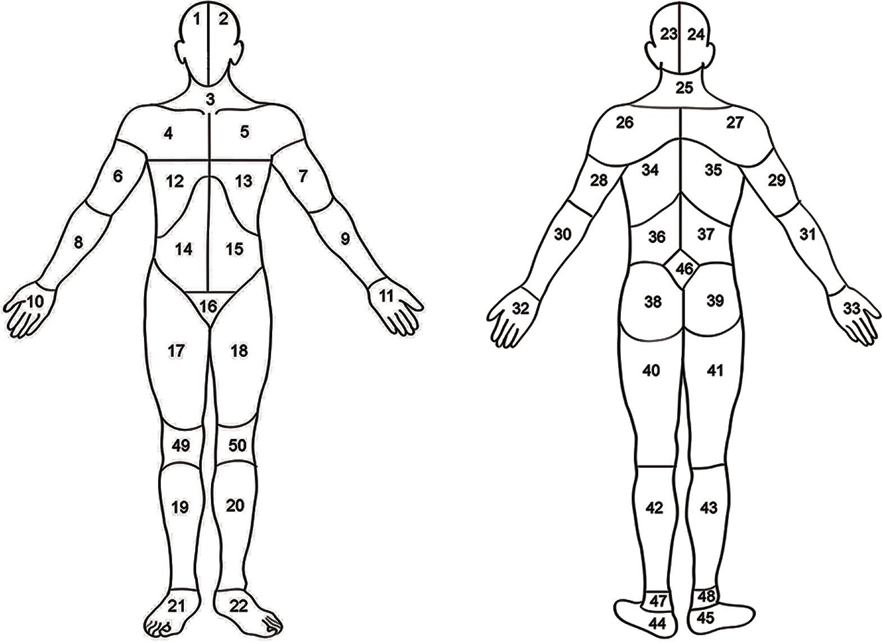
BODY MAP [CHILD]

Significant Occurrence Report No. |  |  |  |  | Date |  |  |  |  |  | Time
Child involved |  |  |  |  |  | DoB
Injury sustained by the child |  |  |  |  |  |  |  | Accident Book  Number
Details of Injury to The Child
(Include Location Number from Body Mop)
How did the injury occur?
Medication attention offered
Indicate any injuries sustained to the child on the diagram below (bruises, marks, grazes, scratches etc.).
FRONT BACK

Right Left Left Right
Child Sign |  |  |  | Name |  |  |  |  | Date
Author |  |  |  |  |  |  |  |  | Date

BODY MAP [STAFF]

Significant Occurrence Report No. |  |  |  | Date |  |  |  |  | Time
Name of Staff member
Injury sustained by the Staff member |  |  |  |  |  | Accident Book Number
Details of Injury to The Staff Member
(Include Location Number from Body Mop)
How did the injury occur?
Medication attention offered?
Indicate any injuries sustained to the member of staff on the diagram below (bruises, marks, grazes, scratches etc.).
FRONT BACK

Right Left Left Right
Staff Sign |  |  | Name |  |  |  | Date
Author |  |  |  |  |  |  | Date

